Experiment 9: Power Transfer in AC Circuits

By:

Shawn Keene, Jason Gilman

Supervisor: Saad Muaddi

Data collected on: 12/02/2019

Due: 12/06/2019

ECEN 214-508, Electrical Circuit Theory

Fall 2019

Prof. Scott Miller

**Procedure:**

For task 1, students built the circuit in figure 9.5 below. Next a sinusoidal input voltage was attached to the circuit with a peak to peak voltage of 8 volts and the frequency was set to 10kHz. Next the potentiometer was set to as close to 20kohms as possible. The load voltage and power dissipated were then calculated. The experiment was repeated for the following load resistor values: 4kohm, 6kohm, 8kohm, 10kohm, 15kohm, and 20kohm.

Next in task 2, students modified the circuit to add a shunt capacitor as shown in figure 9.6. The input frequency was again set to 10kHz and the power dissipated/load voltage in the load resistor was calculated for capacitor values as close to .5nF, .8nF, 1nF, 1.5nF, 2nF, 3nF, and 4nF.

In task 3 instead of just varying the capacitor, students varied both the capacitor and load resistance in order to find the maximum power dissipated. The frequency was again set to 10kHz and the load resistance and capacitance was set to the values calculated in the prelab. As with the previous tasks, the load voltage, load resistance, load capacitance and power dissipated were all recorded.

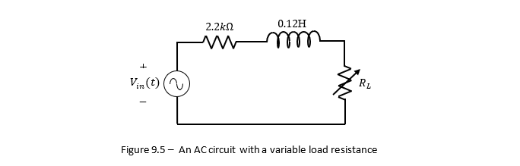

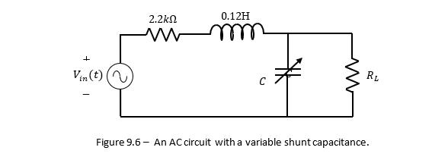

**Data:**

|  |  |  |
| --- | --- | --- |
| Task 1 |  |  |
| Load Resistance (Ohm) | Load Voltage (V) | Power Dissipated (W) |
| 4000 | 1.95E-01 | 0.000004753125 |
| 6100 | 2.59E-01 | 0.000005498442623 |
| 8100 | 3.00E-01 | 0.000005555555556 |
| 10000 | 3.35E-01 | 0.00000561125 |
| 15100 | 3.86E-01 | 0.000004933642384 |
| 20000 | 4.12E-01 | 0.0000042436 |

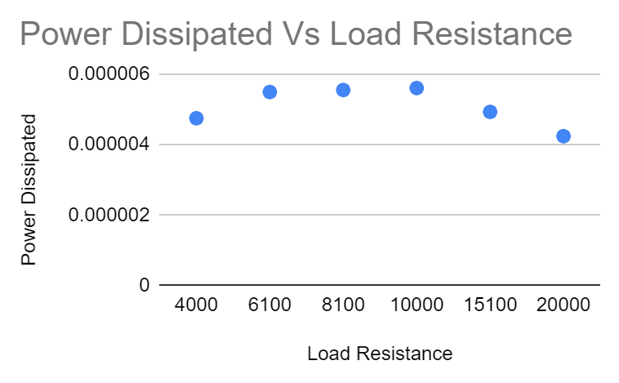

From the data, you can see that 5.6E-6 W was dissipated with a load resistance of 10000 Ohms. The theoretical results showed that with a load resistance of 7854.22 Ohms, there would be 1.9E-4 W dissipated.

|  |  |  |  |
| --- | --- | --- | --- |
| Task 2 |  |  |  |
| Load Resistance (Ohm) | Shunt Capacitor (F) | Load Voltage (V) | Power Dissipated (W) |
| 10000 | 5.00E-10 | 3.65E-01 | 0.00000666125 |
| 10000 | 7.60E-10 | 3.93E-01 | 0.00000772245 |
| 10000 | 1.00E-09 | 4.01E-01 | 0.00000804005 |
| 10000 | 1.65E-09 | 4.25E-01 | 0.00000903125 |
| 10000 | 1.98E-09 | 3.94E-01 | 0.0000077618 |
| 10000 | 3.33E-09 | 3.63E-01 | 0.00000658845 |
| 10000 | 4.00E-09 | 2.61E-01 | 0.00000340605 |

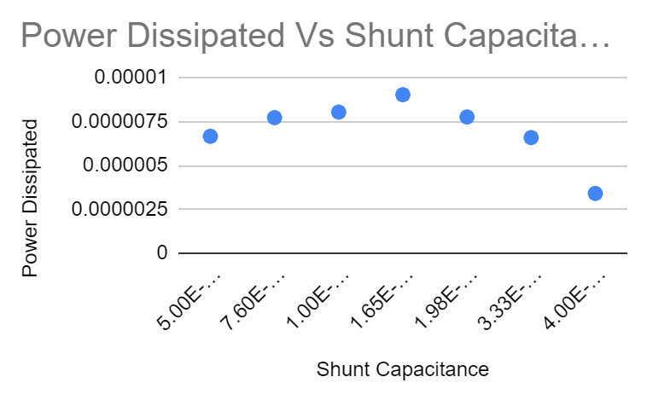

The greatest power dissipated in task 2 was with a load resistor of 10000 Ohms, because this produced the greatest power in task 1. The capacitance that produced the greatest power was 1.65 nF, which was the closest to 1.5 nF that was possible. The power dissipated was 9.0E-6 W. The theoretical results showed that with a load resistance of 7854.22 Ohms, and a capacitance of 3E-9, there would be 1.44E-4 W dissipated.

|  |  |  |  |
| --- | --- | --- | --- |
| Task 3 |  |  |  |
| Load Resistance (Ohm) | Shunt Capacitor (F) | Load Voltage (V) | Power Dissipated (W) |
| 10000 | 1.65E-09 | 4.25E-01 | 0.00000903125 |
| 28400 | 1.98E-09 | 6.70E-01 | 0.000007903169014 |

From the table, you can see that a load resistance of 10000 Ohms, and a capacitance of 1.65 nF would dissipate 9.0E-6 W of power. The theoretical results showed that with a load resistance of 28400 Ohms, and a capacitance of 1.98 nF, 7.9E-6 W would be dissipated.

**Discussion:**

The difference between the theoretical values of the load resistance, power dissipated, and capacitors and the real values are significant. THe actual best load resistance was 2000 ohms more than calculated, and the best capacitance was 1.5nF less than the theoretical values. These errors can be attributed to both real resistors and capacitors not being 100% precise and with the amount of error between the theoretical and real values the calculations in the prelab can straight up be wrong. With the amount of derivations that have to be done for power transfer, one mistake can make the entire answer be off. In general, optimizing for maximum power transfer is something every electrical engineer should do. The best power dissipated that was able to be gotten out of optimizing the circuit was 9E-6 W. Compare this to the lowest power dissipated which was 3.4E-6 W, when you optimize power you can get almost 3 times the power than you would if you did not.